

**FPTU Event management**

**Software Requirement Specification**

**Version 1.0**

**Prepared by**

**Nguyễn Thành Trung**

**Phan Minh Nhựt**

**Trịnh Nam Anh**

–Ho Chi Minh, November 2021 –

Table of Contents

I. Overview 4

1. Introduction 5

2. Use Cases 5

3. System Functions 5

4. Common Requirements 5

II. Functional Requirements 5

1. Common features 5

a. Login 5

b. Register 5

c. Open User menu 5

d. View profile 5

e. Edit profile 5

f. Log out 5

2. Basic User Features 5

a. View events 5

b. View posts 5

c. View followed events 5

d. View event details 5

e. View post details 5

f. Follow/Unfollow an event 5

g. Join/Unjoin an event 5

3. Event Manager Features 5

a. Create an event 5

b. View created events 5

c. Edit an event 5

4. Mentor/Lecturer Features 5

a. Create a post 5

b. View created posts 5

c. Edit a post 5

5. Administrator Features 5

a. Switch to Admin mode 5

b. Switch to User mode 5

c. User management 5

d. Location management 5

III. Non-Functional Requirements 5

1. Security 5

2. Performance 5

3. External requirements 5

# I. Overview

## 1. Introduction

Currently, there are many events taking place at FPTU HCM which can come from a department, or several school clubs. The problem encountered by students is that there are many events that occur at the same time or there are many events that students are interested in but cannot keep track of the progress of the events. Moreover, departments and clubs cannot set up a schedule of events that will take place during the week, month, quarter, etc. This will lead to inefficiently events’ experience for the hosts and participants.

This system was made to help departments and clubs post upcoming events, helping students to follow one or more events that students love and care about. The system also helps departments and clubs to upload a photo and embed videos of the event that took place. At the same time, students can also follow and leave their comments. Beside of those, this system can also help manage the locations for hosting events and user accounts.

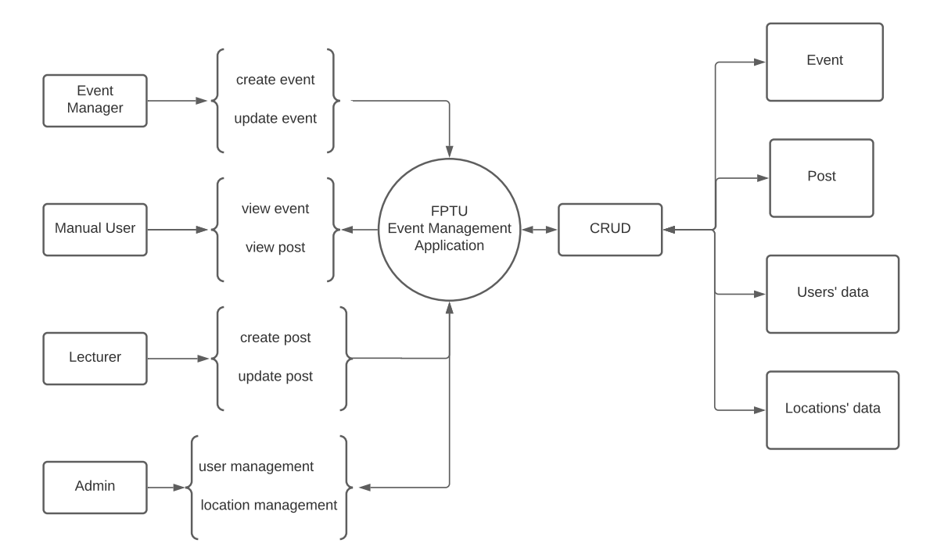

**Figure 1** – *Context Diagram of FPTU Event Management Application System*

## 2. Use Cases

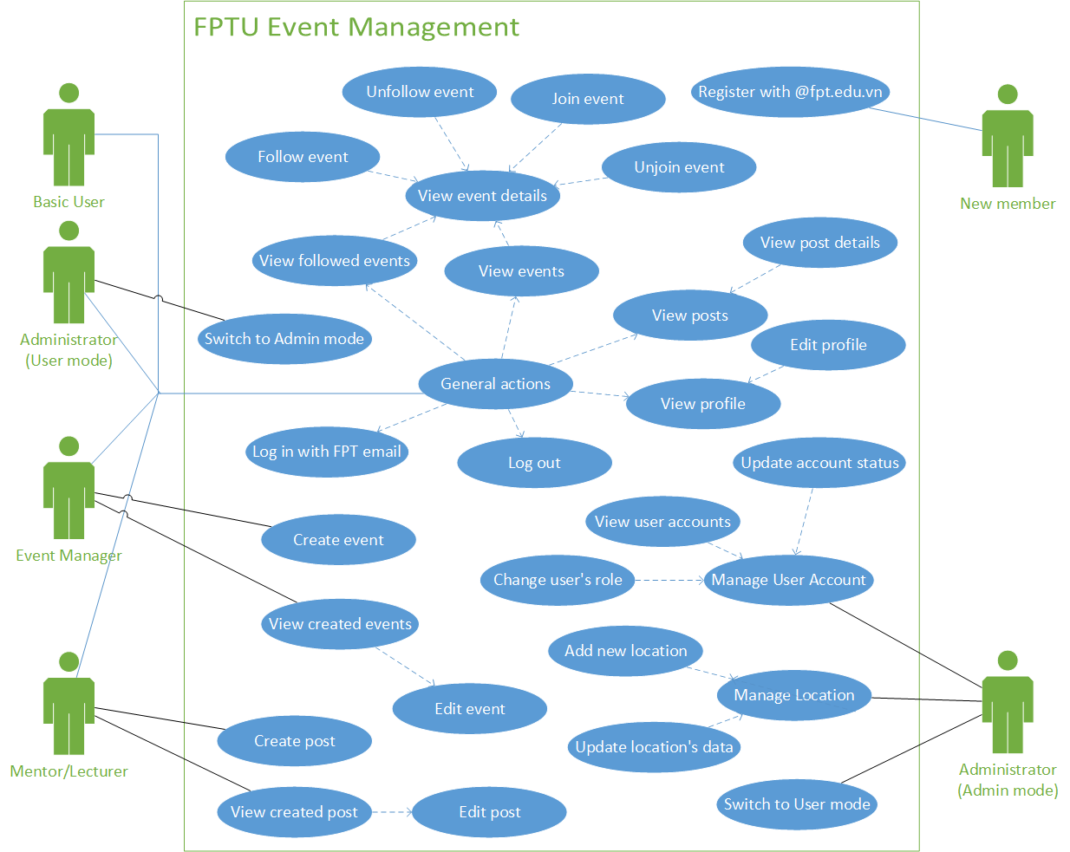

## 3. System Functions

#### a. Screen Flow

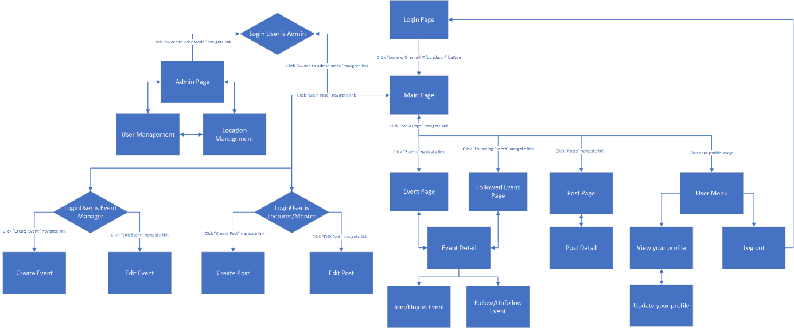

#### b. Screen Details

|  |  |  |  |
| --- | --- | --- | --- |
| **#** | **Feature** | **Screen** | **Description** |
| 1 | Login | Login Page | User logs in to the web application by clicking “Login with email @fpt.edu.vn” button |
| 2 | Register | Login Page | User registers and logs in to the web application by clicking “Login with email @fpt.edu.vn” button |
| 3 | View events and posts | Main Page | First encounter page after logged in |
| 4 | View events only | Event Page | Click “Events” navigate link on the top sidebar |
| 5 | View selected event’s detail | Event Detail | Click on selected event’s name |
| 6 | Follow event | Event Detail | Click “Follow” button in the box on the right of the screen |
| 7 | Unfollow event | Event Detail | Click “Followed” button in the box on the right of the screen |
| 8 | Join event | Event Detail | Click “Join” button in the box on the right of the screen |
| 9 | Unjoin event | Event Detail | Click “Joined” button in the box on the right of the screen |
| 10 | View followed events only | Followed Event Page | Click “Following Events” navigate link on the top sidebar |
| 11 | View posts only | Post Page | Click “Posts” navigate link on the top sidebar |
| 12 | View selected post’s detail | Post Detail | Click on selected post’s name |
| 13 | Open user menu | User Menu | Click on profile’s picture |
| 14 | View profile | View your profile | Click on “Profile” button in “User Menu” (13) |
| 15 | Update username | Update your profile | Edit your name then click “Edit Name” |
| 16 | Log out to Login Page | Logout | Click on “Logout” button in “User Menu” (13) |
| 17 | Switch to Admin mode | Main Page | Click on “Switch to Admin mode” navigate link on the top sidebar. Only if login user is admin |
| 18 | Switch to User mode | Admin Page | Click on “Switch to User mode” navigate link on the top sidebar. Only if login user is admin |
| 19 | Manage users | Admin Page | Click on “User Management” navigate link on the top sidebar. Only if login user is admin and within admin mode |
| 20 | Manage locations | Admin Page | Click on “Location Management” navigate link on the top sidebar. Only if login user is admin and within admin mode |
| 21 | Create event | Create Event | Click on “Create Event” navigate link on the top sidebar. Only if login user is event manager |
| 22 | Edit event | Edit Event | Click on “Edit Event” navigate link on the top sidebar. Only if login user is event manager |
| 23 | Create post | Create Post | Click on “Create Post” navigate link on the top sidebar. Only if login user is lecturer/mentor |
| 24 | Edit post | Edit Post | Click on “Edit Post” navigate link on the top sidebar. Only if login user is lecturer/mentor |

c. User Authorization

|  |  |  |  |  |  |
| --- | --- | --- | --- | --- | --- |
| **Screen** | **Basic** | **Admin**  **AM** | **Admin**  **UM** | **EM** | **ML** |
| Login Page |  |  |  |  |  |
| Login | X |  | X | X | X |
| Register | X |  |  |  |  |
| Main Page |  |  |  |  |  |
| View Events | X |  | X | X | X |
| View Posts | X |  | X | X | X |
|  |  |  |  |  |  |
| Switch to Admin mode |  |  | X |  |  |
| Switch to User mode |  | X |  |  |  |
| Event Page |  |  |  |  |  |
| View Events | X |  | X | X | X |
| Event Detail |  |  |  |  |  |
| View Event’s Detail | X |  | X | X | X |
| Follow/Unfollow Event | X |  | X | X | X |
| Join/Unjoin Event | X |  | X | X | X |
| Followed Event Page |  |  |  |  |  |
| View Followed Events | X |  | X | X | X |
| Post Page |  |  |  |  |  |
| View Posts | X |  | X | X | X |
| Post Detail |  |  |  |  |  |
| View Post’s Detail | X |  | X | X | X |
| User Menu |  |  |  |  |  |
| Profile |  |  |  |  |  |
| View profile | X |  | X | X | X |
| Update username | X |  | X | X | X |
| Logout | X |  | X | X | X |
| Admin Page |  |  |  |  |  |
| User Management (CRUD*) |  | X |  |  |  |
| Location Management (CRUD*) |  | X |  |  |  |
| Create Event |  |  |  | X |  |
| Edit Event |  |  |  |  |  |
| View Events (which is belong to login user) |  |  |  | X |  |
| Update Selected Event’s Detail |  |  |  | X |  |
| Create Post |  |  |  |  | X |
| Edit Post |  |  |  |  |  |
| View Posts (which is belong to login user) |  |  |  |  | X |
| Update Selected Post’s Detail |  |  |  |  | X |

In which:

* Basic: “Basic user” such as Student, Staff, etc who can only do all the basic general actions.
* Admin AM: “Admin (Admin mode)” as admin within duty of user and location management.
* Admin UM: “Admin (User mode)” as admin not in duty of management, treated as “Basic user”
* EM: “Event Manager” as who host events.
* ML: “Mentor/Lecturer” as who post the posts about the specified event.
* CRUD*: Add, Get, Update or Remove a record.

## 4. Common Requirements

* Operating Environment:
  + The FPTU Event Management website shall be compatible with every standard web browser on Windows, Mac platforms. Supported browsers are Internet Explorer 8, Microsoft Edge, Google Chrome 10, Opera 10, Opera GX, Firefox and later.
  + The FPTU Event Management website shall operate on Apache Tomcat Server 8.0.27.
  + The FPTU Event Management website support view only on resolution 1980 x 1200px screen.
  + The FPTU Event Management does not support view on any handheld devices’ platforms.
* Assumptions and Dependencies
  + The system uses Microsoft SQL Server as system’s database.
  + The website uses Google API to verify @fpt.edu.vn email to permit logged in or registered users.
  + The website uses JDK 1.8 as Java platform.
  + The website uses gson-2.8.0.jar, httpclient-4.5.5.jar, fluent-hc-4.5.5.jar, httpcore-4.4.9.jar for Google authentication.
  + The website use commons-fileupload-1.4.jar for uploading images to the system.
  + The website use sqljdbc4.jar for interacting with SQL database.

# II. Functional Requirements

## 1. Common features

### a. Login/Register

* *Function trigger: when user enter the page.*
* *Function description: all users, for authentication.*
* *Function details: user chose email @fpt.edu.vn to login.*
* *Screen layout:*

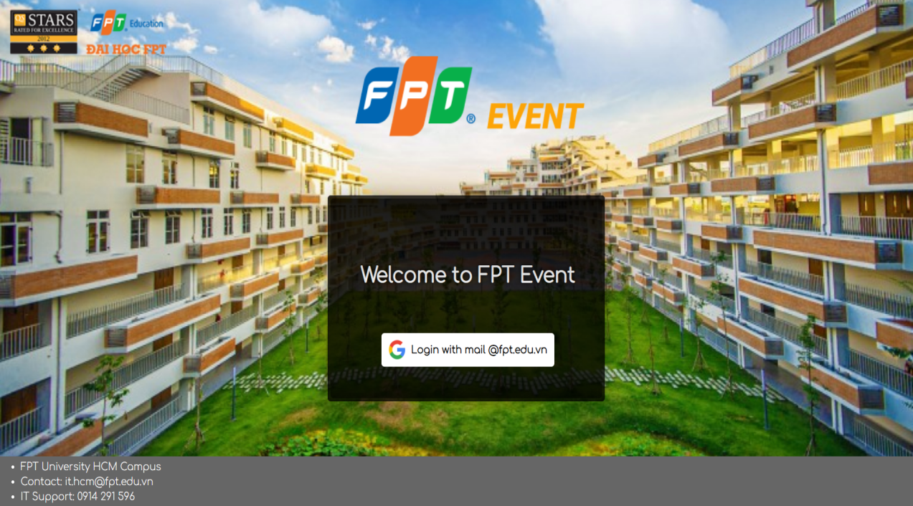

***Figure 2*** *- Login function*

### b. Open User menu

* *Function trigger: click the avatar on the top right corner.*
* *Function description: all users.*
* *Function details: user click the avatar to open the menu.*
* *Screen layout:*

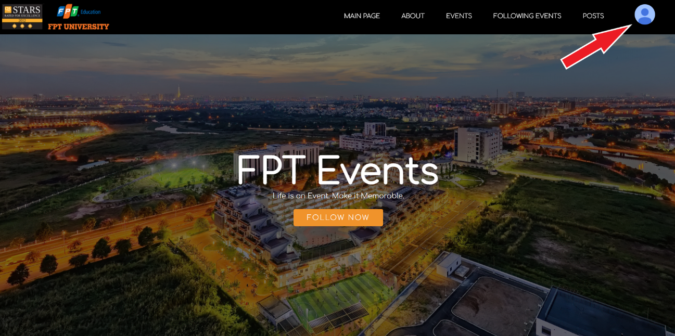

***Figure 3*** *- Open user menu*

### c. View profile

* *Function trigger: chose option ‘Profile’ on the drop down menu.*
* *Function description: all users.*
* *Function details: user chose the option ‘Profile’ to open user’s profile.*
* *Screen layout:*

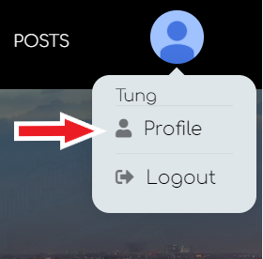

***Figure 4.1*** *- View profile*

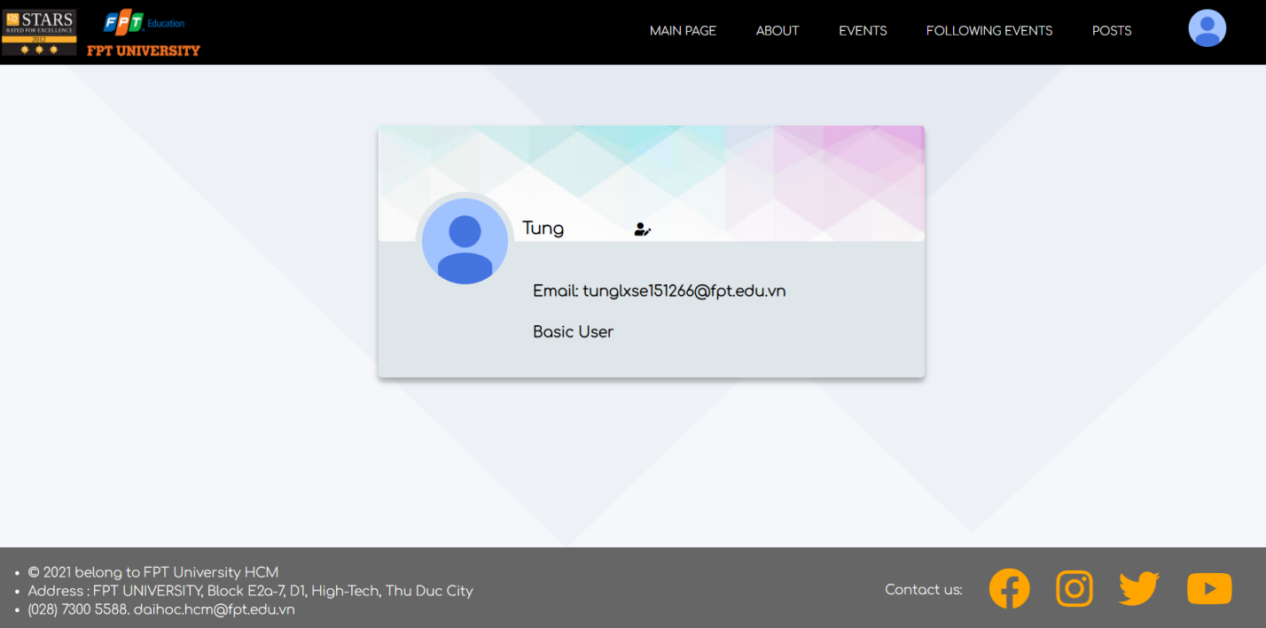

***Figure 4.2*** *- View profile*

### d. Edit profile

* *Function trigger: user click on the icon .*
* *Function description: all users.*
* *Function details: user click the icon to edit name, press Enter to confirm the change.*
* *Screen layout:*

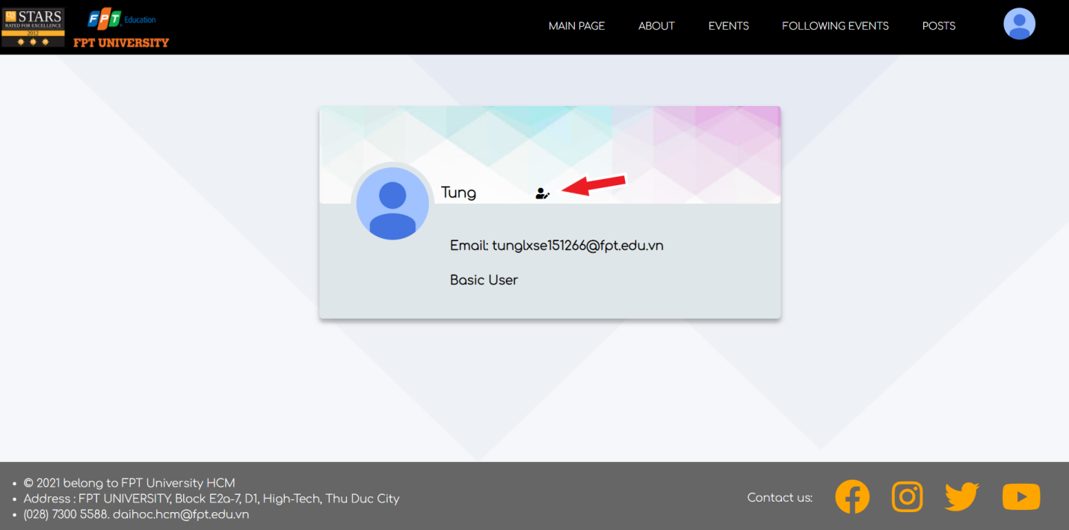

***Figure 5.1*** *- Edit profile*

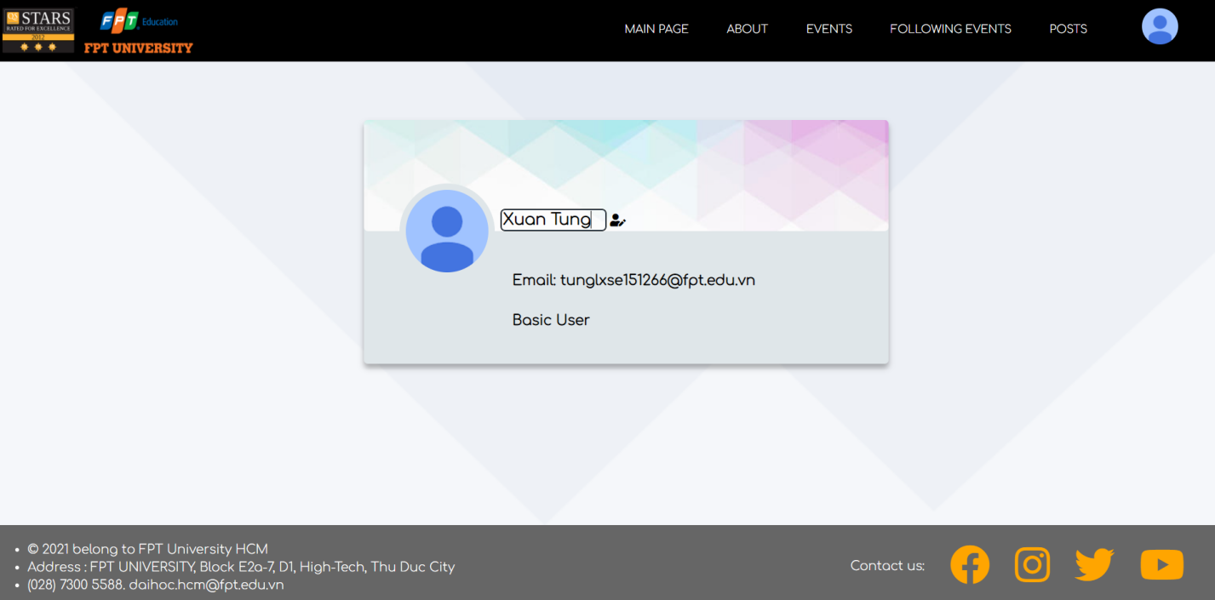

***Figure 5.2 -*** *Edit profile*

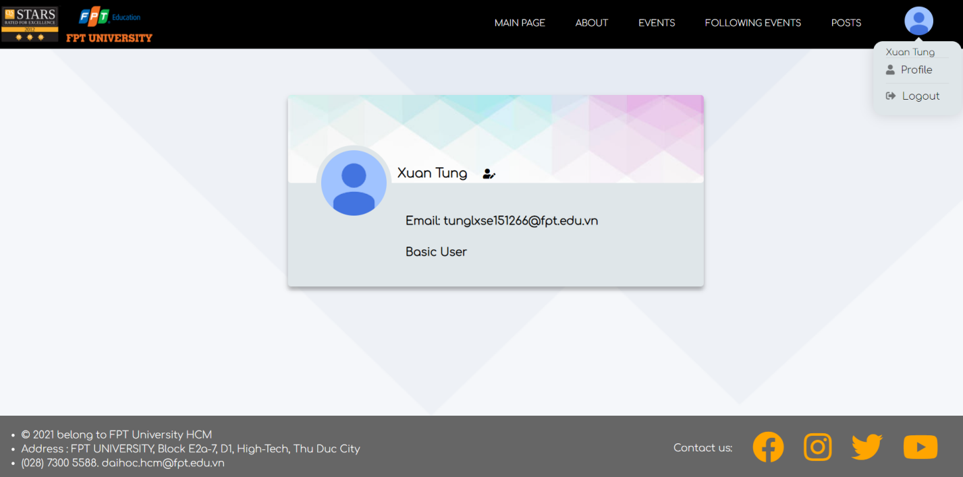

***Figure 5.3***  *- After changed*

### e. Log out

* *Function trigger: user chose ‘Logout’ option on the drop down menu.*
* *Function description: users who have authenticated.*
* *Function details: user chose the option ‘Logout’ on the the dorp down menu to logout.*
* *Screen layout:*

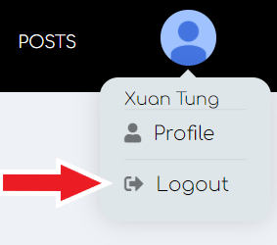

***Figure 6*** *- Logout function*

## 2. Basic User Features

### a. View events

* *Function trigger: user click ‘Follow Now’ button on the main page or ‘Events’ button on the navigation bar.*
* *Function description: users who have authenticated.*
* *Function details: user clicked ‘Follow Now’ button will be navigated to the event section on main page with six closet events, user can also click ‘Show more’ button to view more events. User clicked ‘Events’ button on the navigation bar will be led to events page with all events.*
* *Screen layout:*

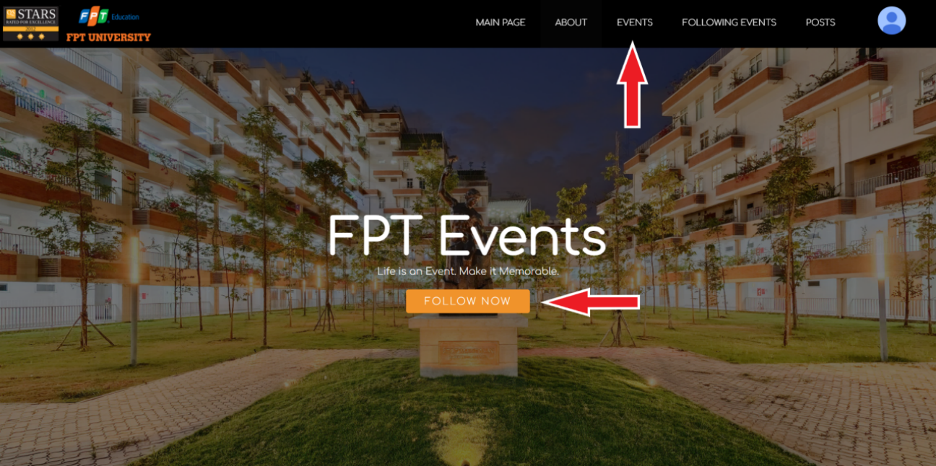

***Figure 7.1*** *- View events*

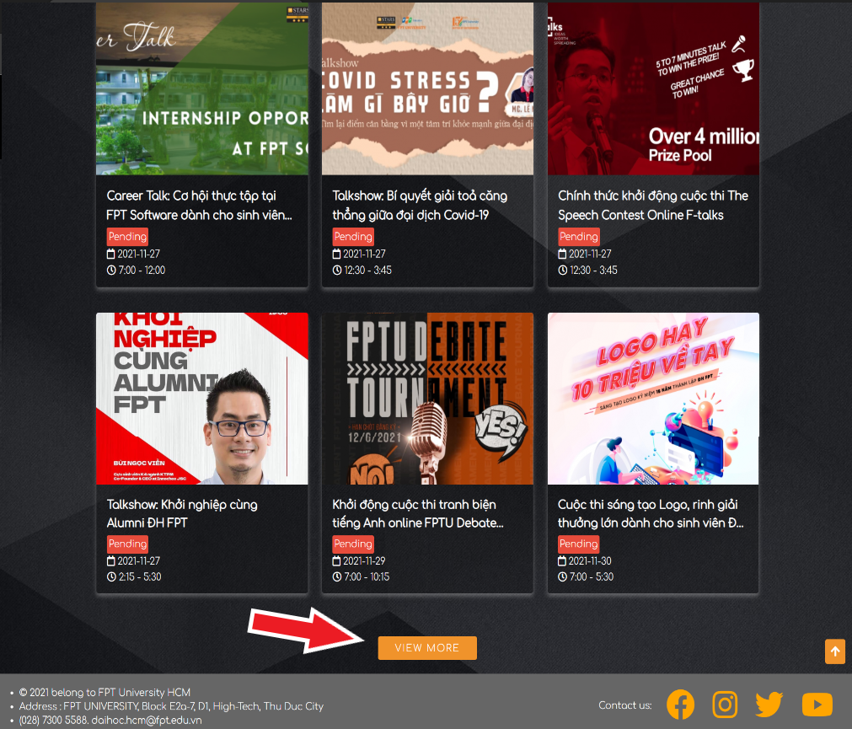

***Figure 7.2*** *- View events on main page*

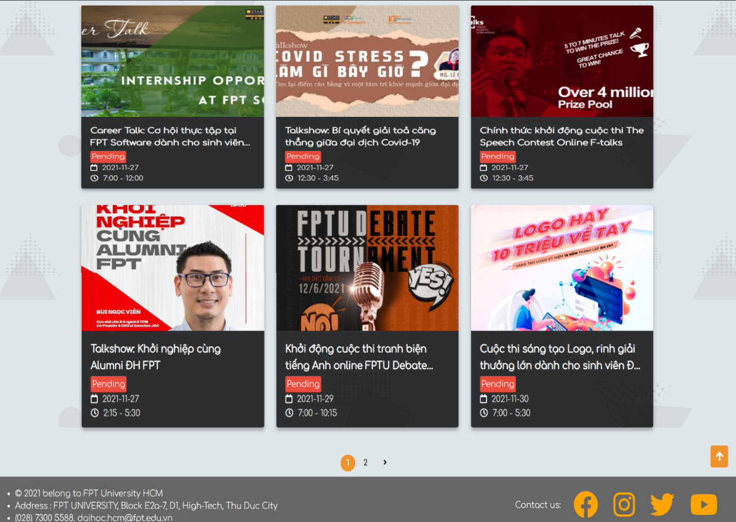

***Figure 7.3*** *- View more events*

### b. View posts

* *Function trigger: use click ‘Posts’ button on the navigation bar.*
* *Function description: users who have authenticated.*
* *Function details: user can scroll down to see some related posts and user can also click ‘Show more’ button to view more posts. User clicked ‘Posts’ button on the navigation bar will be led to the view posts page with all posts.*
* *Screen layout:*

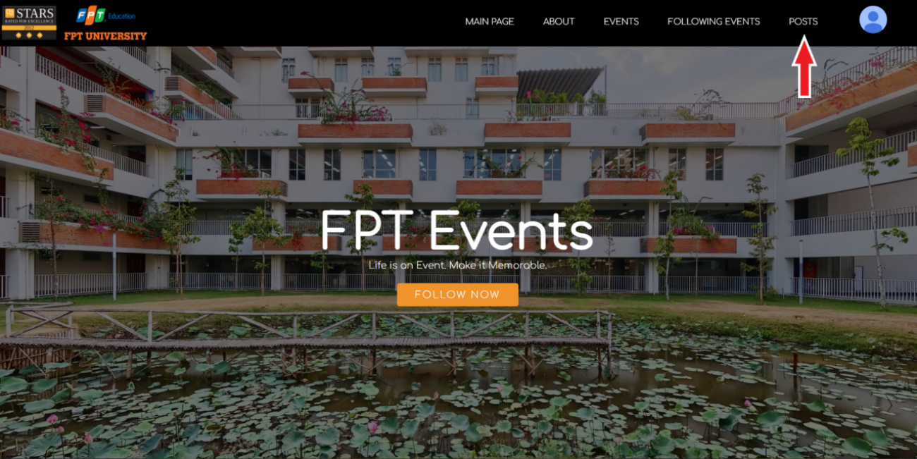

***Figure 8.1*** *- View posts*

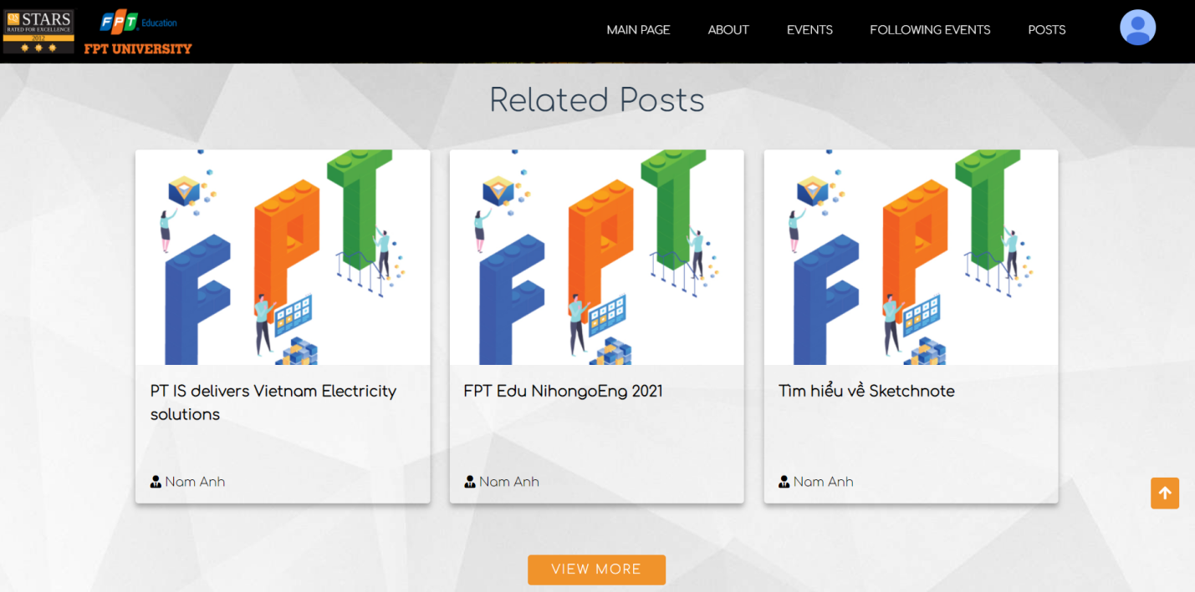

***Figure 8.2*** *- View posts on main page*

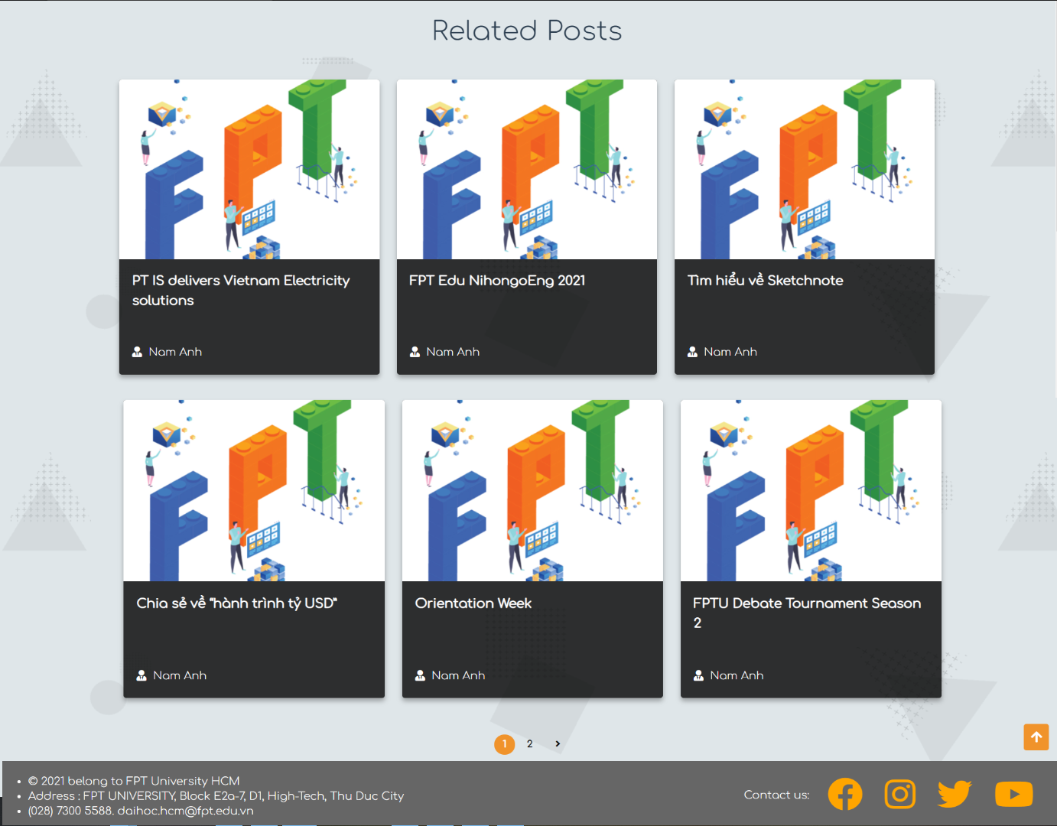

***Figure 8.3***  *- View more posts*

### c. View followed events

* *Function trigger: user click ‘Following Events’ button on the navigation bar.*
* *Function description: users who have authenticated.*
* *Function details: show all the following events of user.*
* *Screen layout:*

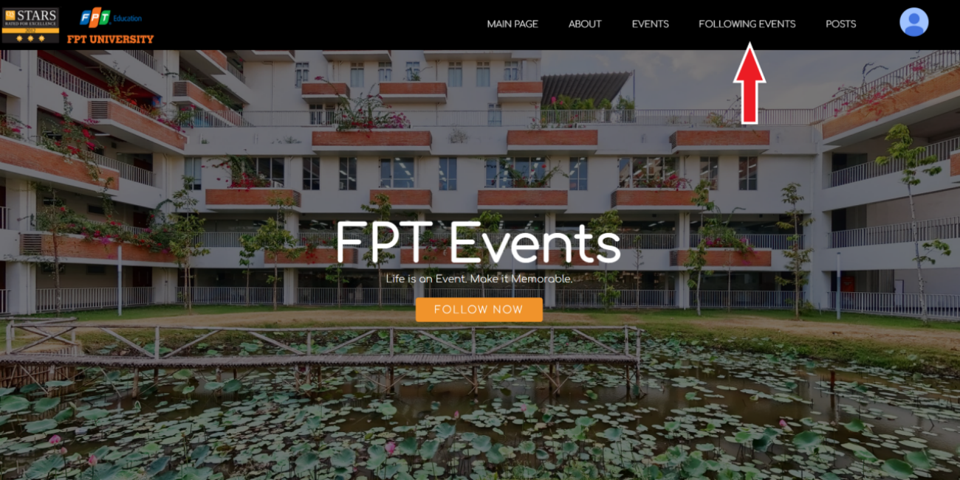

***Figure 9.1*** *- View following events*

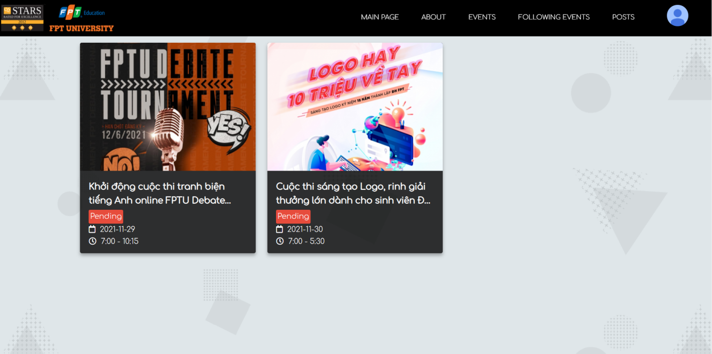

***Figure 9.2***  *- View following events*

### d. View event details

* *Function trigger: user click on any event.*
* *Function description: users who have authenticated.*
* *Function details: show the detail of selected event.*
* *Screen layout:*

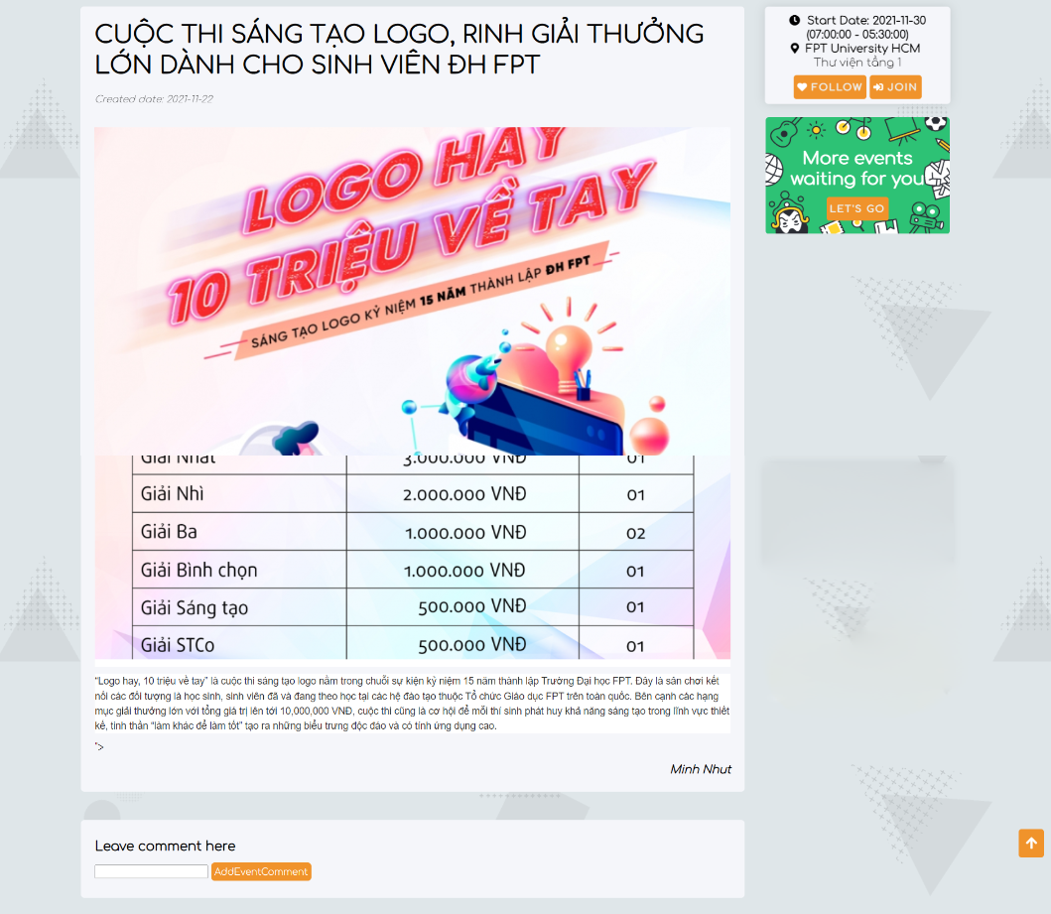

***Figure 10*** *- View event details*

### e. View post details

* *Function trigger: user click on any post.*
* *Function description: users who have authenticated.*
* *Function details: show all the detail of selected post.*
* *Screen layout:*

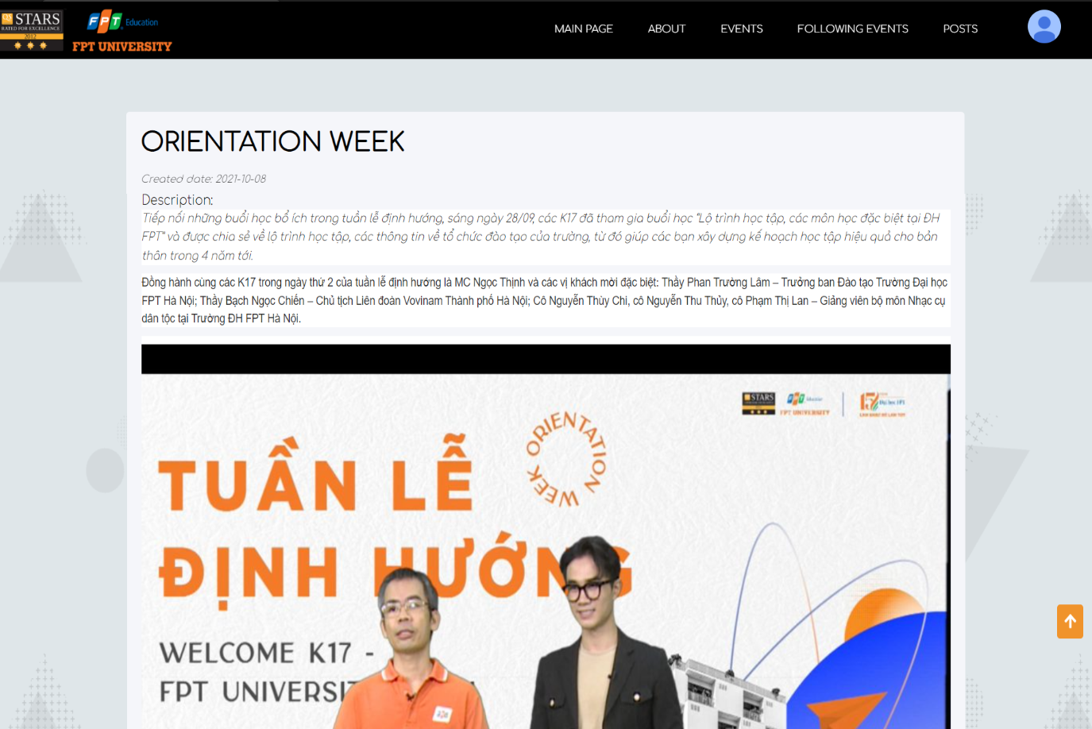

***Figure 11*** *- View post details*

### f. Follow/Unfollow an event

* *Function trigger: user click ‘Follow’ button.*
* *Function description: users who have authenticated.*
* *Function details: click ‘Follow’ button on the right side in the event detail, click again to unfollow.*
* *Screen layout:*

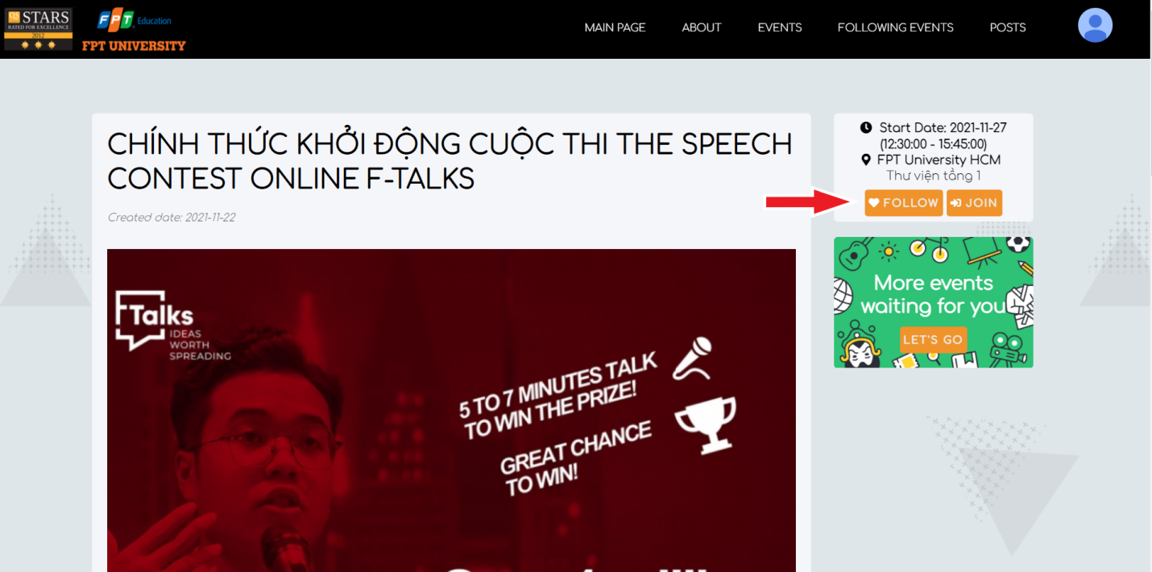

***Figure 12.1*** *- Follow event*

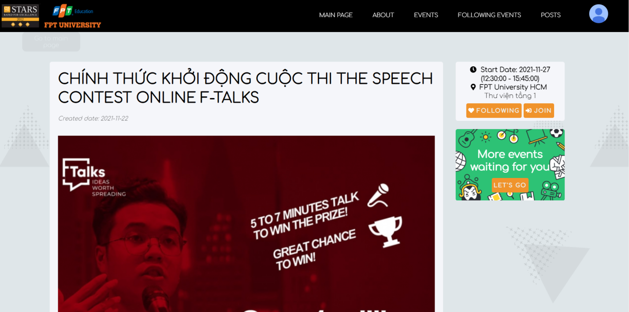

***Figure 12.2*** *- Following event*

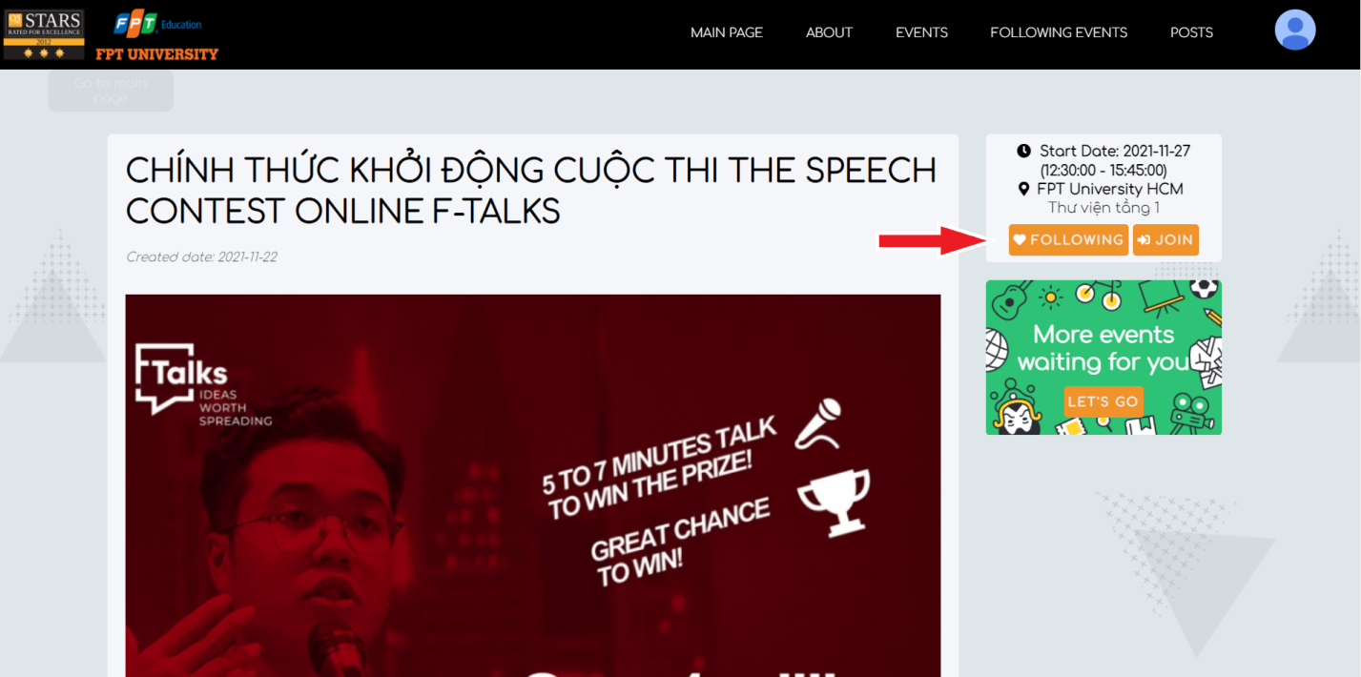

***Figure 12.3*** *- Unfollow event*

### g. Join/Unjoin an event

* *Function trigger: user click ‘Join’ button.*
* *Function description: users who have authenticated.*
* *Function details: click ‘Join’ button on the right side in the event detail, click again to unjoin.*
* *Screen layout:*

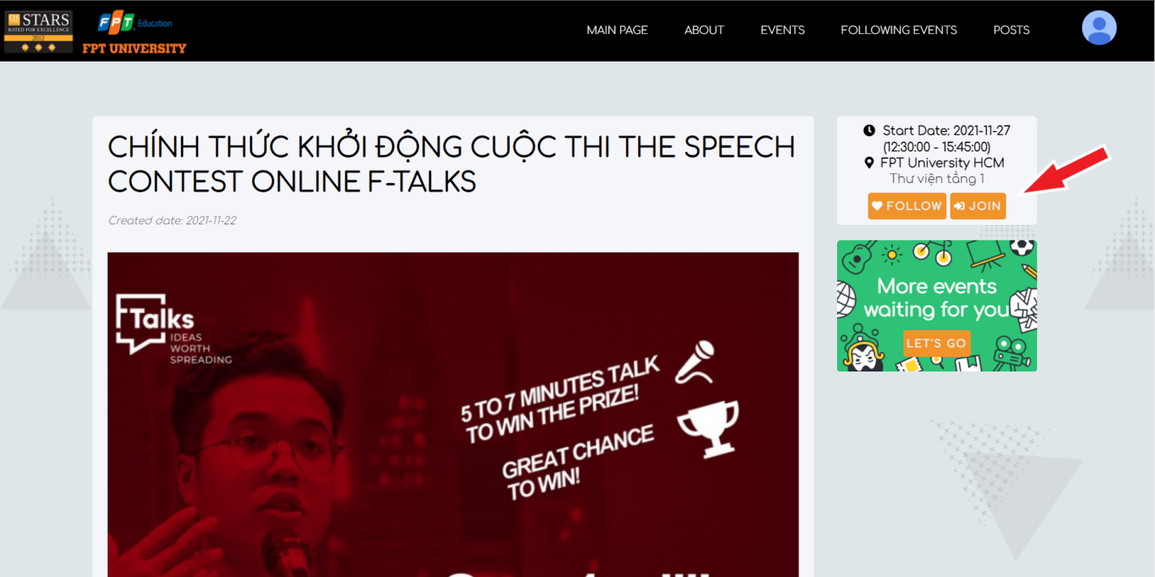

***Figure 13.1 -*** *Join event*

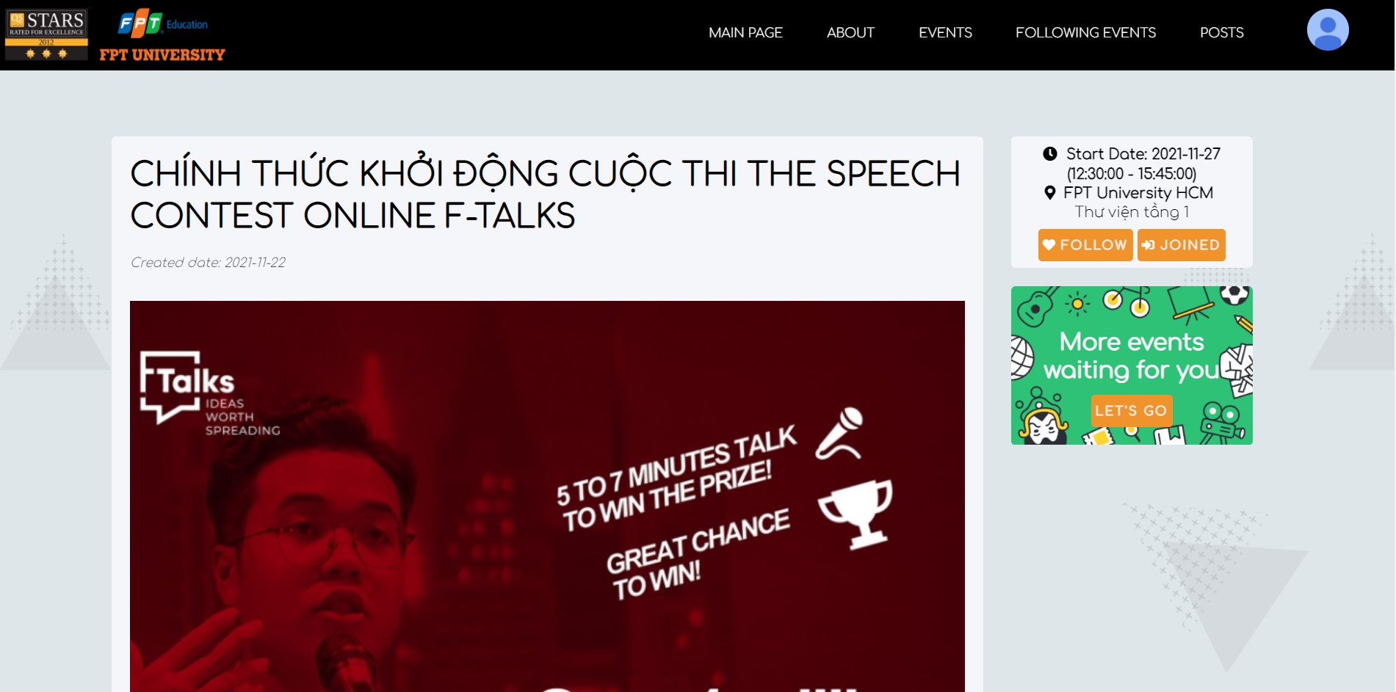

***Figure 13.2***  *- Joined event*

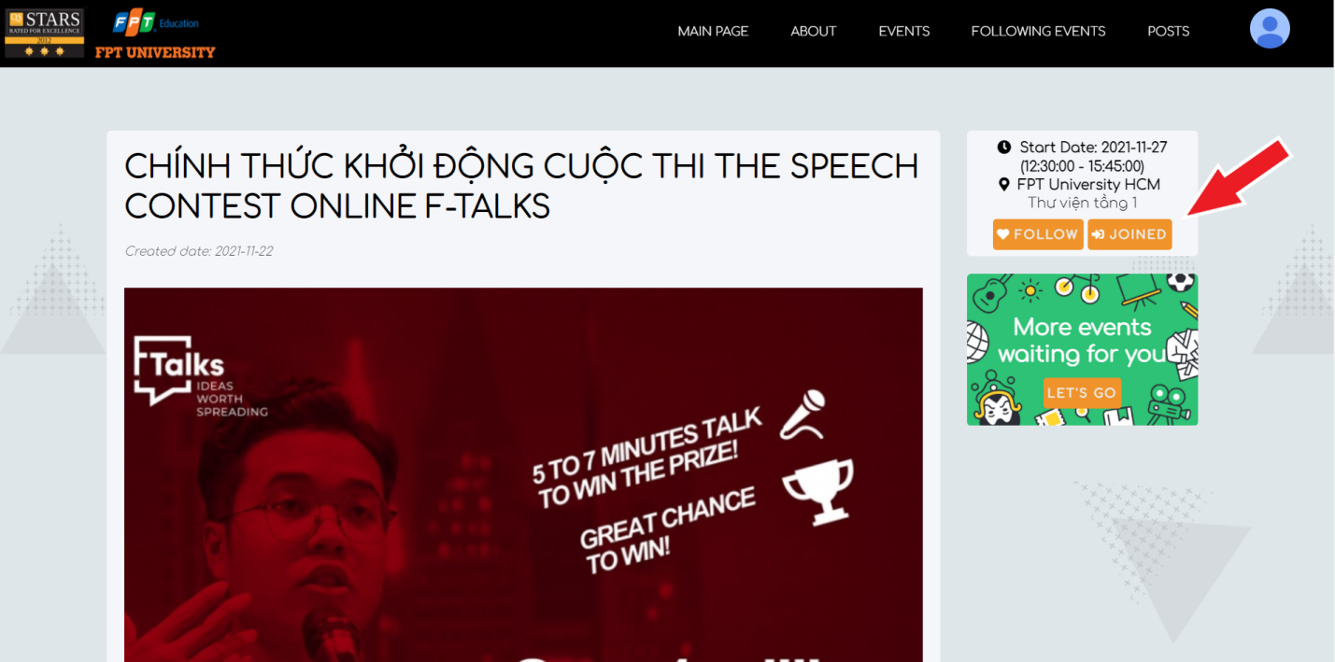

***Figure 13.3***  *- Unjoin event*

## 3. Event Manager Features

### a. Create an event

* *Function trigger: user click ‘Create Events’ button on the navigation bar.*
* *Function description: users who have authenticated as event manager.*
* *Function details: link to new page to create a new event, user fill in the information of the new event .*
* *Screen layout:*

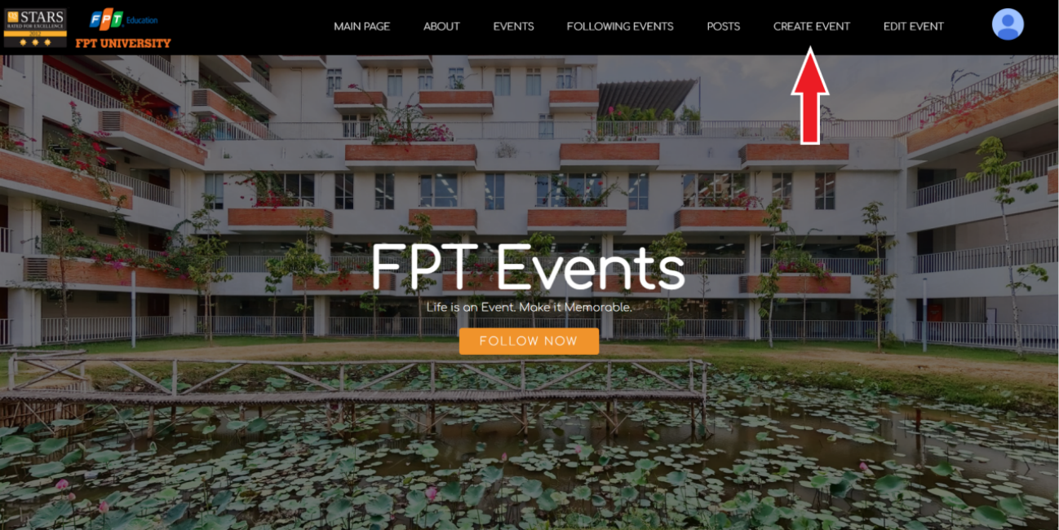

***Figure 14.1*** *- Create event*

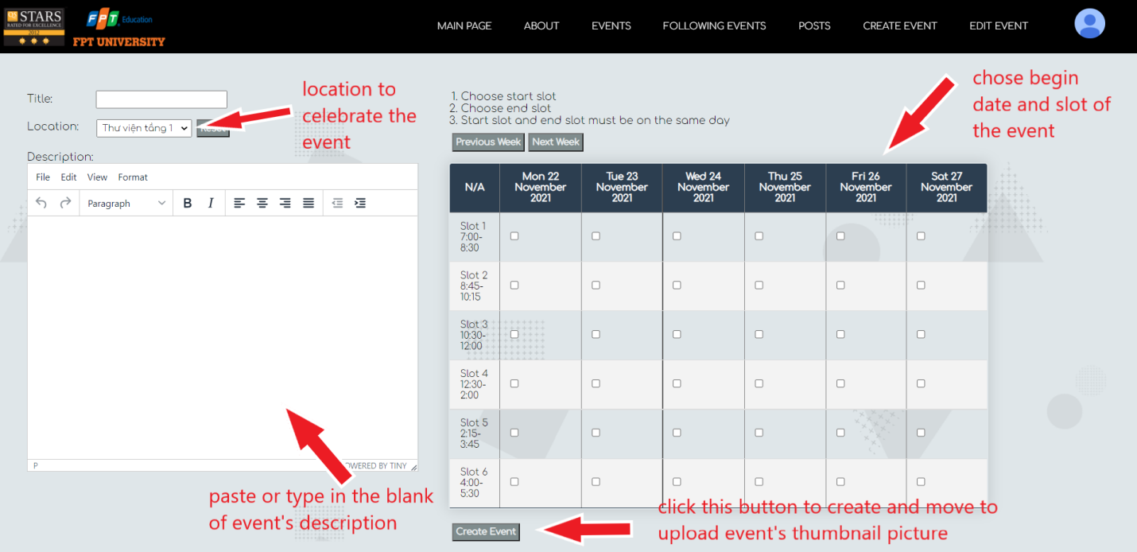

***Figure 14.2 -*** *Fill in detail of event*

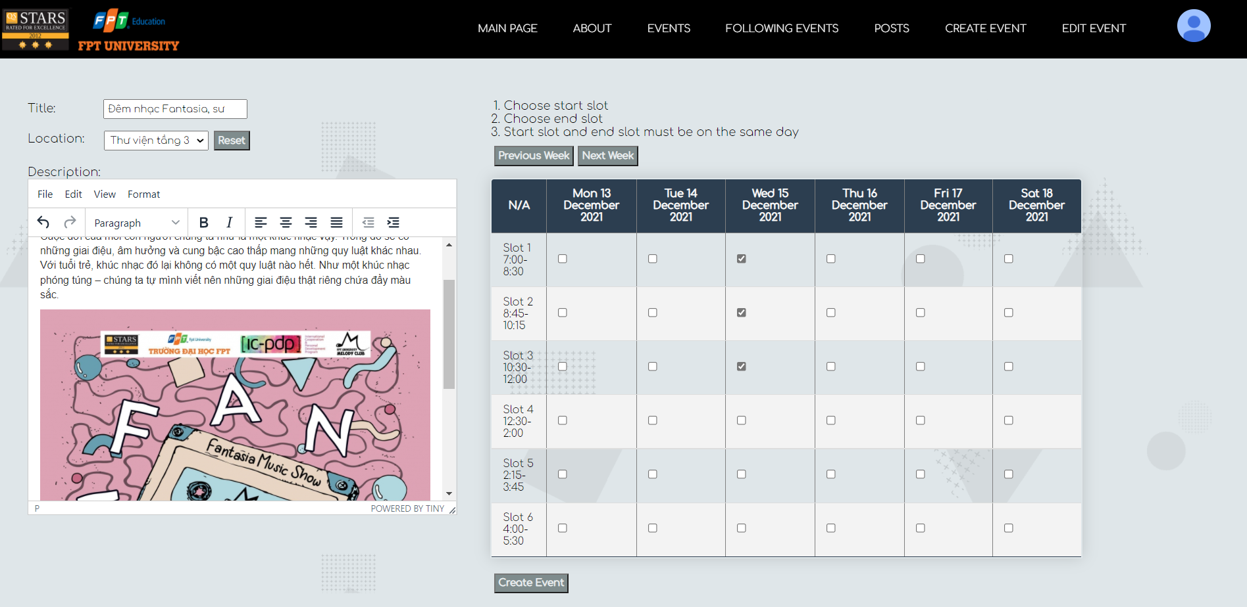

***Figure 14.3*** *- Fill in detail of event*

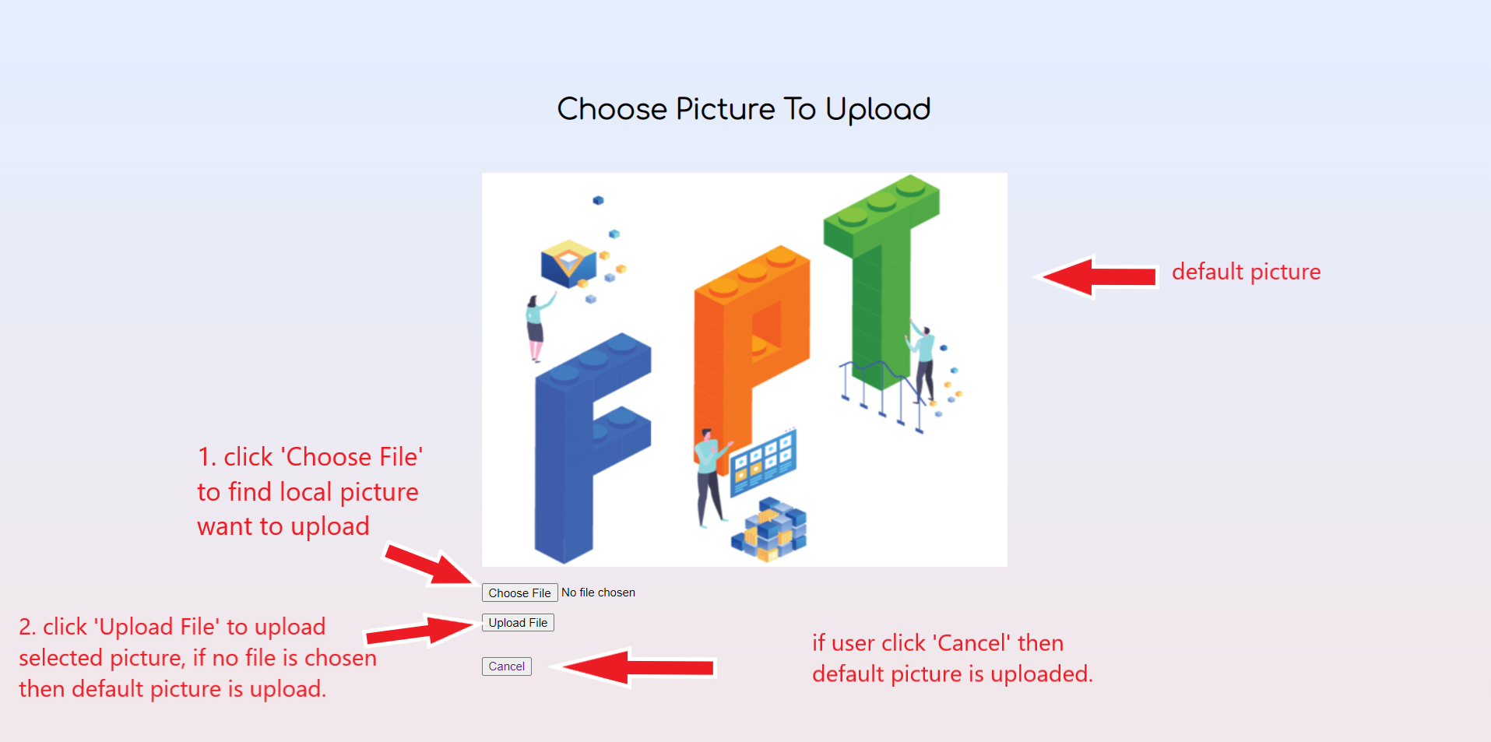

***Figure 14.4 -*** *Upload thumbnail event picture*

### b. View created events

* *Function trigger: user click ‘Upload File’ or ‘Cancel’ button when creating event.*
* *Function description: users who have authenticated as event manger.*
* *Function details: show created event.*
* *Screen layout:*

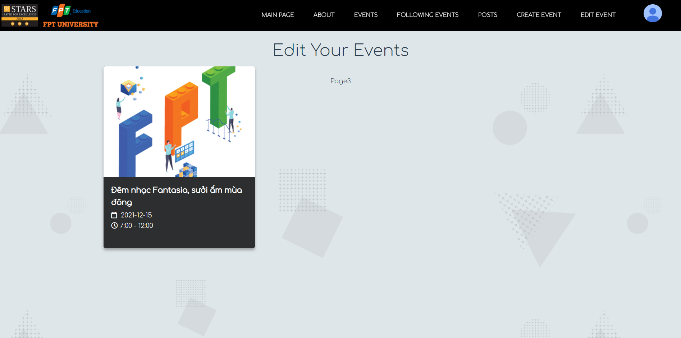

***Figure 15*** *- Created event*

### c. Edit an event

* *Function trigger: user click ‘Edit Event’ button on navigation bar.*
* *Function description: users who have authenticated event manager that create the event.*
* *Function details: chose the event which is created by user to edit or remove.*
* *Screen layout:*

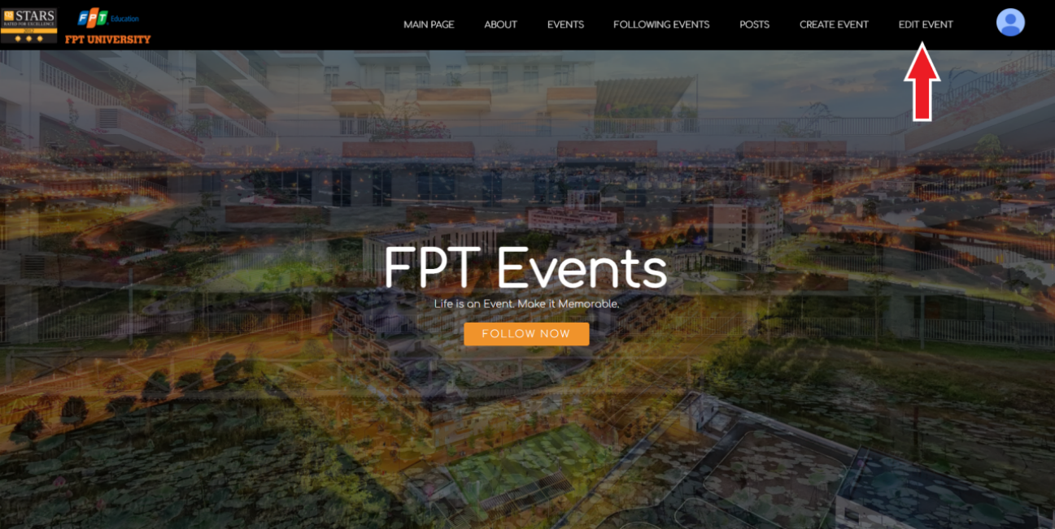

***Figure 16.1***  *- Edit event*

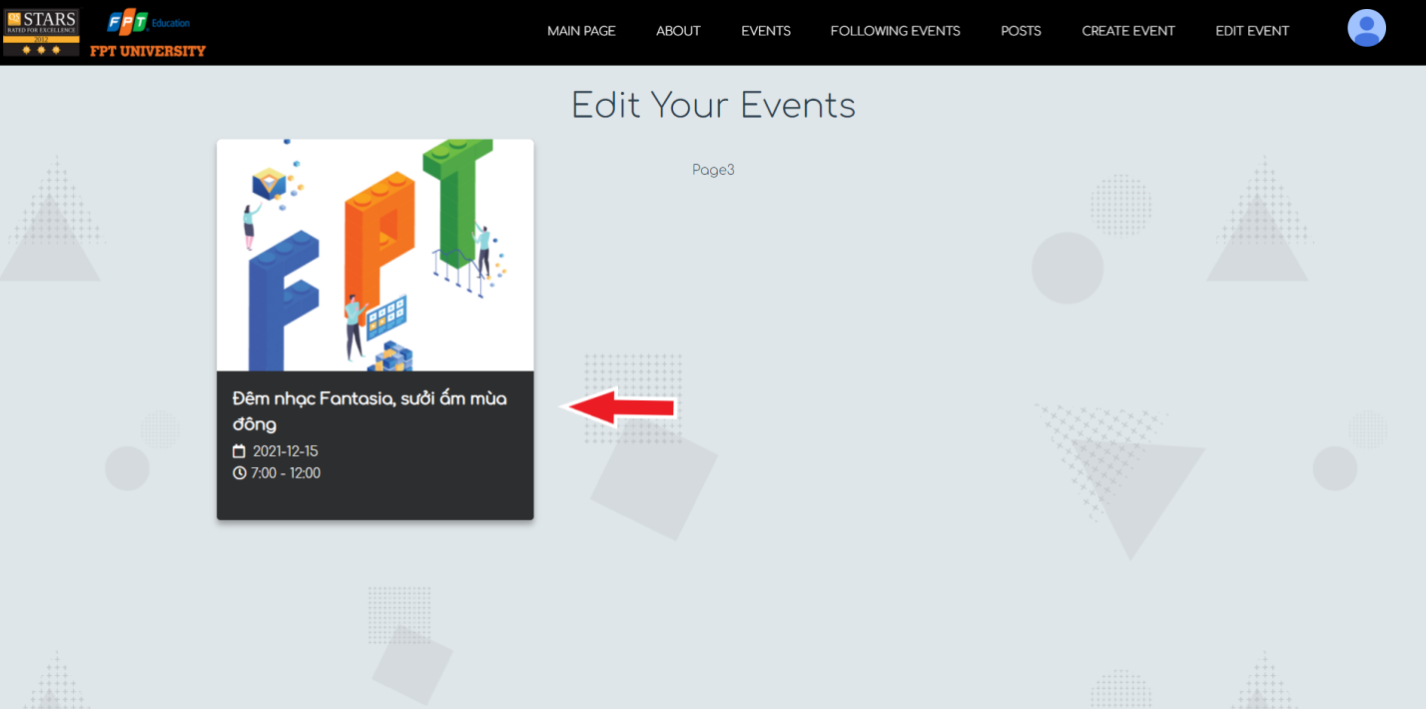

***Figure 16.2***  *- Choose the event to edit*

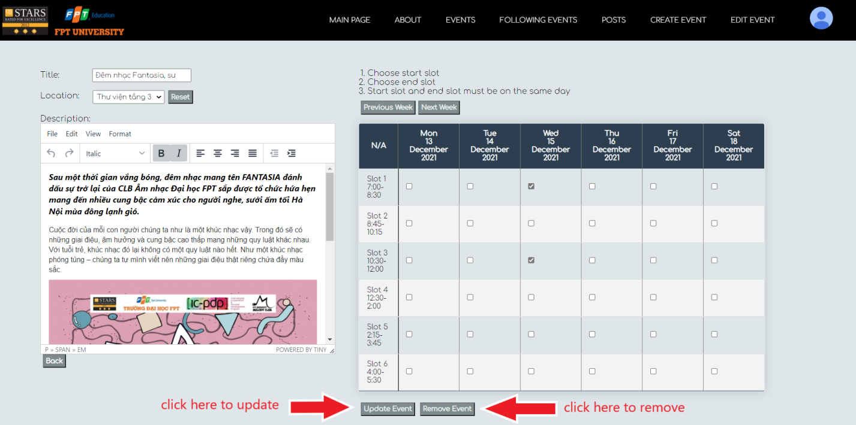

***Figure 16.3 -*** *Edit or remove event*

## 4. Mentor/Lecturer Features

### a. Create a post

* *Function trigger: user click ‘Create Posts’ button on the navigation bar.*
* *Function description: users who have authenticated as mentor/lecturer.*
* *Function details:link to new page to create a new post, user fill in the information of the new post.*
* *Screen layout:*

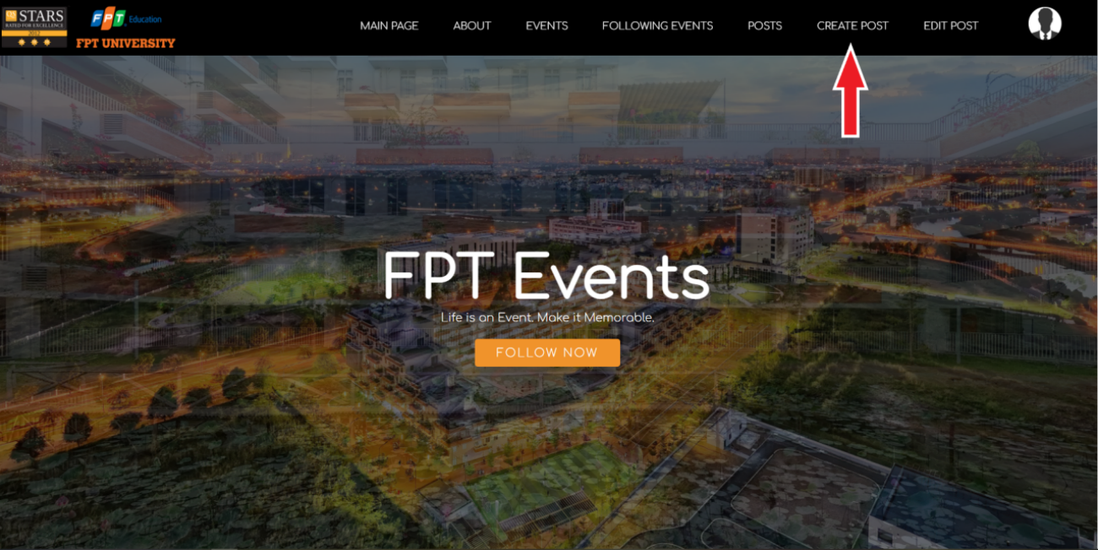

***Figure 17.1*** *- Create post*

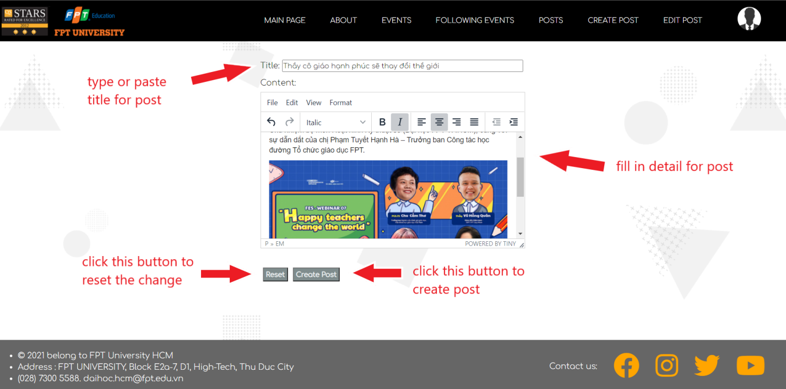

***Figure 17.2*** *- Fill in detail for post*

**

***Figure 17.3*** *- Choose thumbnail picture for the post*

### b. View created posts

* *Function trigger: user click ‘Upload File’ or ‘Cancel’ button when creating post.*
* *Function description: users who have authenticated as mentor/lecture.*
* *Function details: show created post.*
* *Screen layout:*

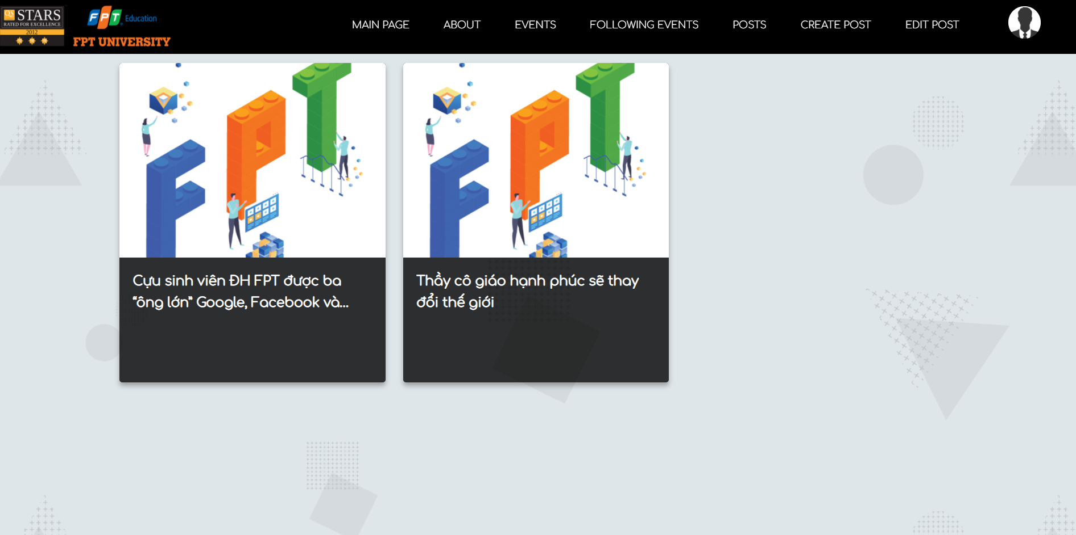

***Figure 18*** *- View created post*

### c. Edit a post

* *Function trigger: user click ‘Edit Post’ button on navigation bar.*
* *Function description: users who have authenticated as mentor/lecturer that create the event.*
* *Function details: chose the post which is created by user to edit or remove.*
* *Screen layout:*

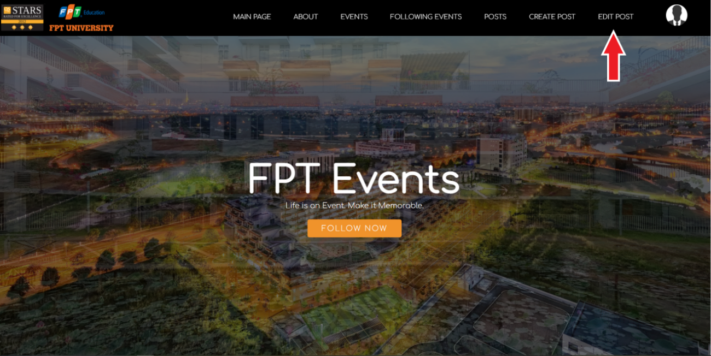

***Figure 19.1*** *- Edit post*

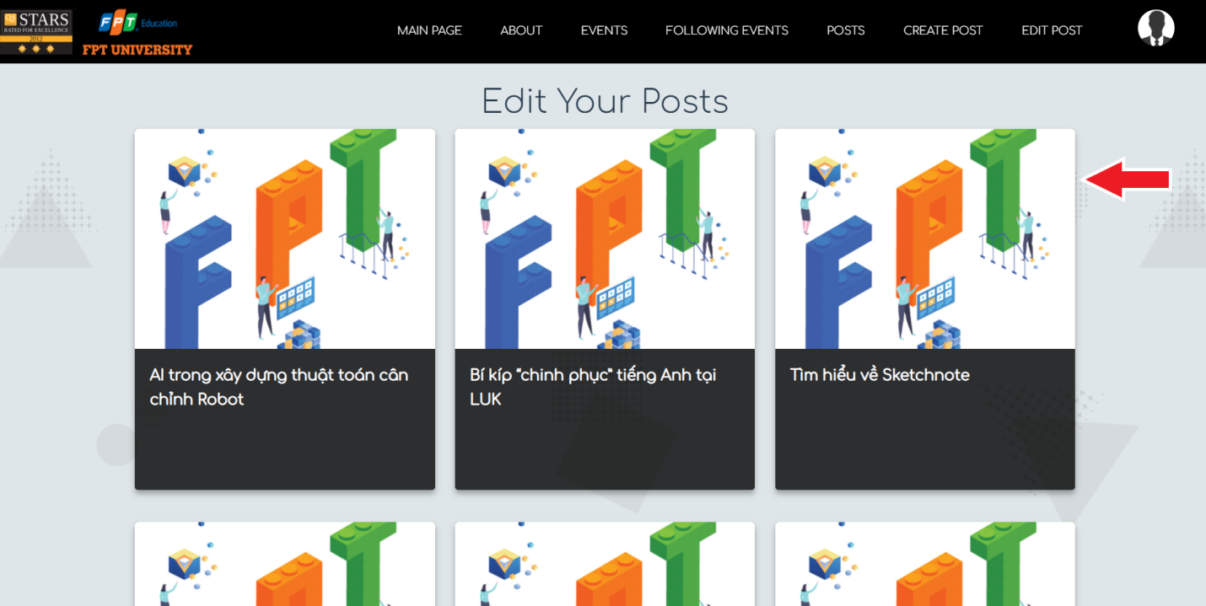

***Figure 19.2*** *- Choose post to edit*

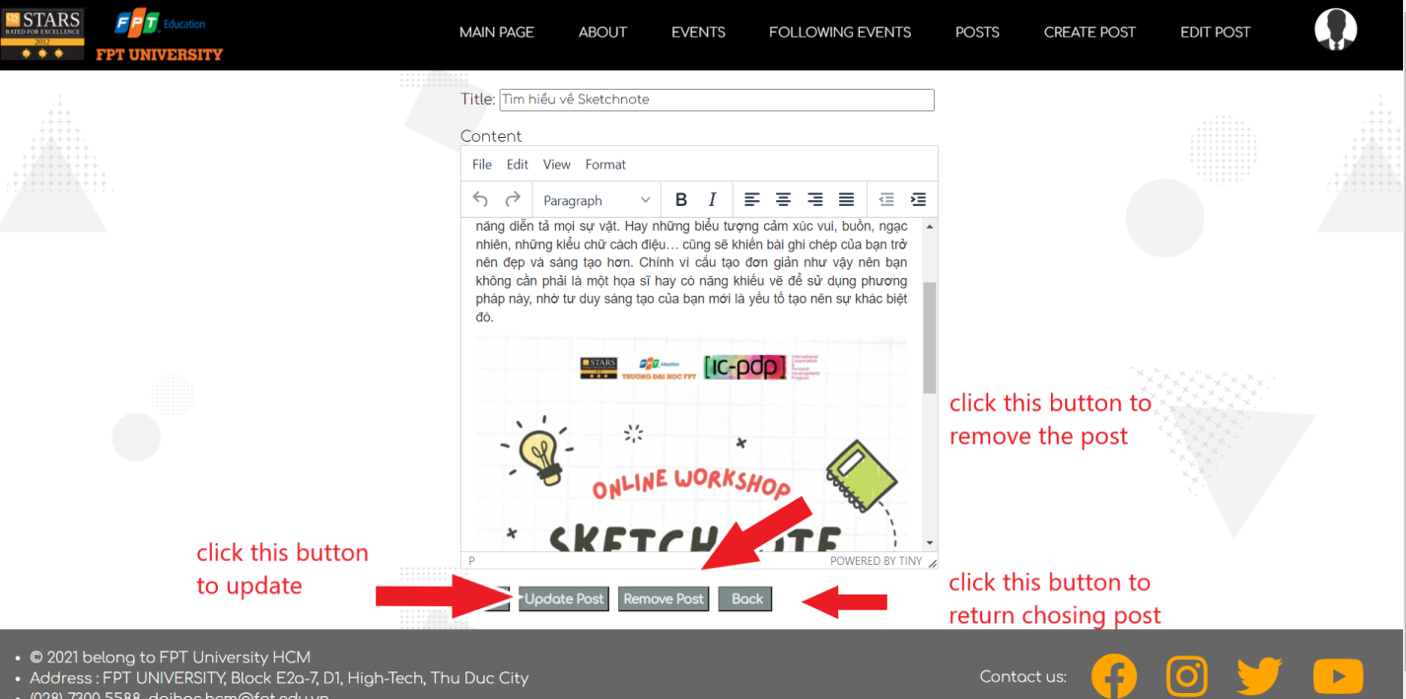

***Figure 19.3*** *- Update or remove post*

## 5. Administrator Features

### a. Switch to Admin mode

* *Function trigger: user click ‘Switch To Admin Mode’ button on the navigation bar.*
* *Function description: users who have authenticated as admin.*
* *Function details: access admin mode.*
* *Screen layout:*

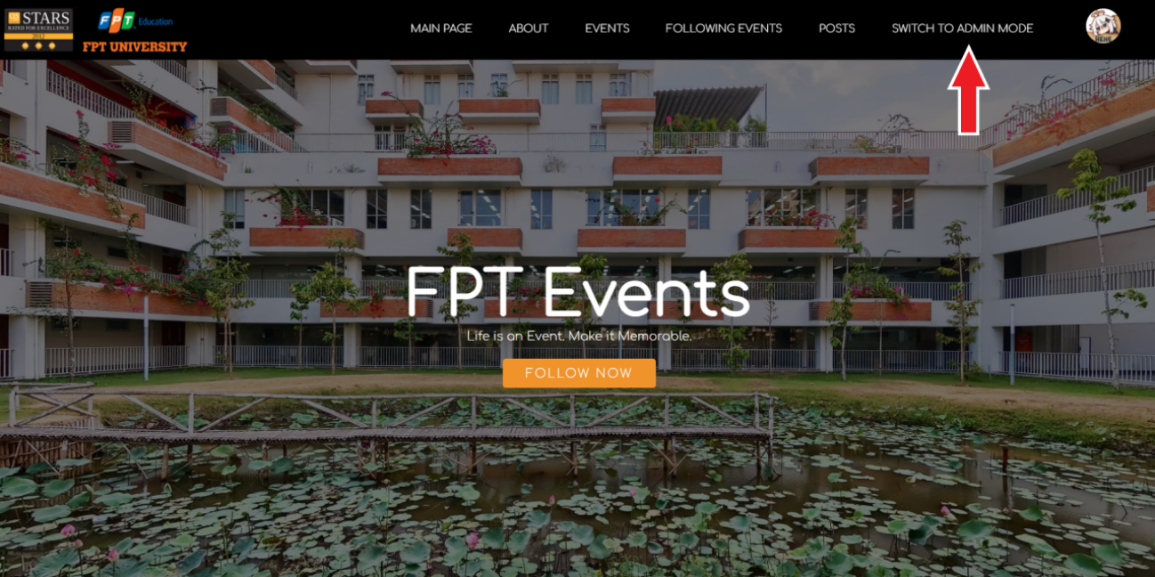

***Figure 20*** *- Switch to Admin mode*

### b. Switch to User mode

* *Function trigger: user click ‘Switch To User Mode’ button on the navigation bar.*
* *Function description: users who have authenticated as admin.*
* *Function details: switch back to user mode after some manage in admin mode.*
* *Screen layout:*

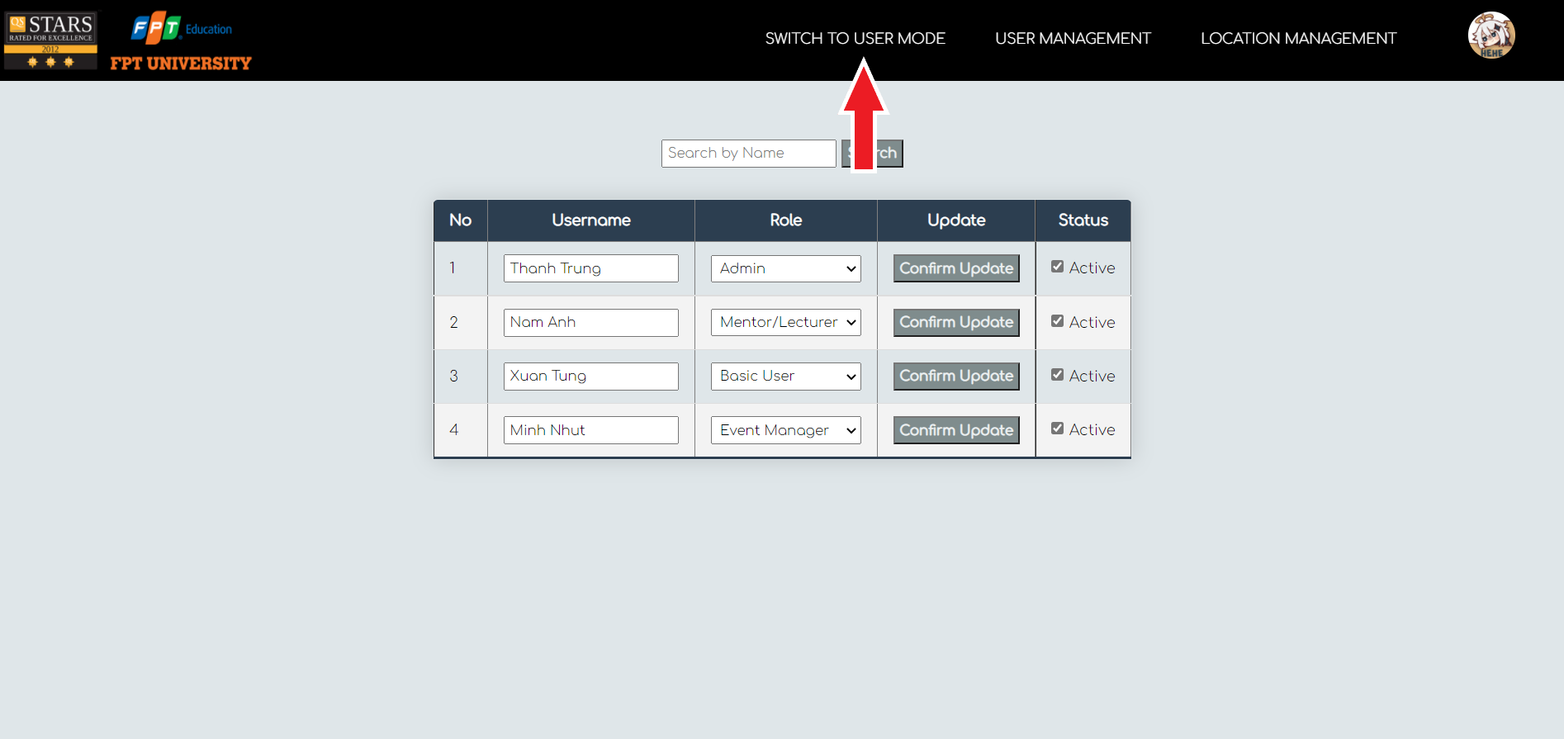

***Figure 21*** *- Switch to User mode*

### c. User management

* *Function trigger: user click ‘User management’ button on the navigation bar.*
* *Function description: users who have authenticated as admin.*
* *Function details: change user role or ban.*
* *Screen layout:*

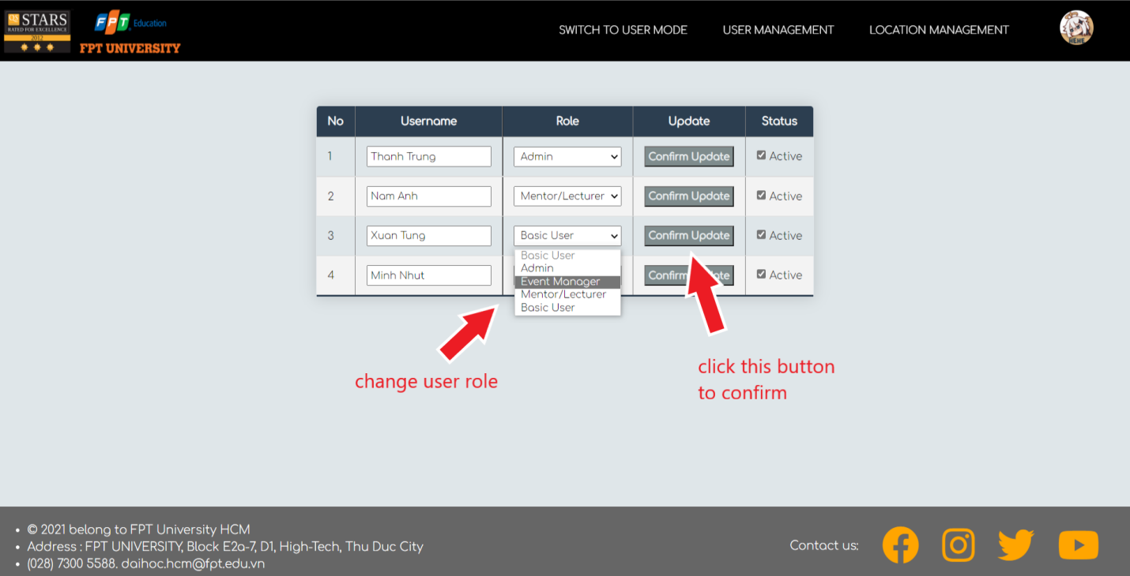

***Figure 22.1*** *- Change user role*

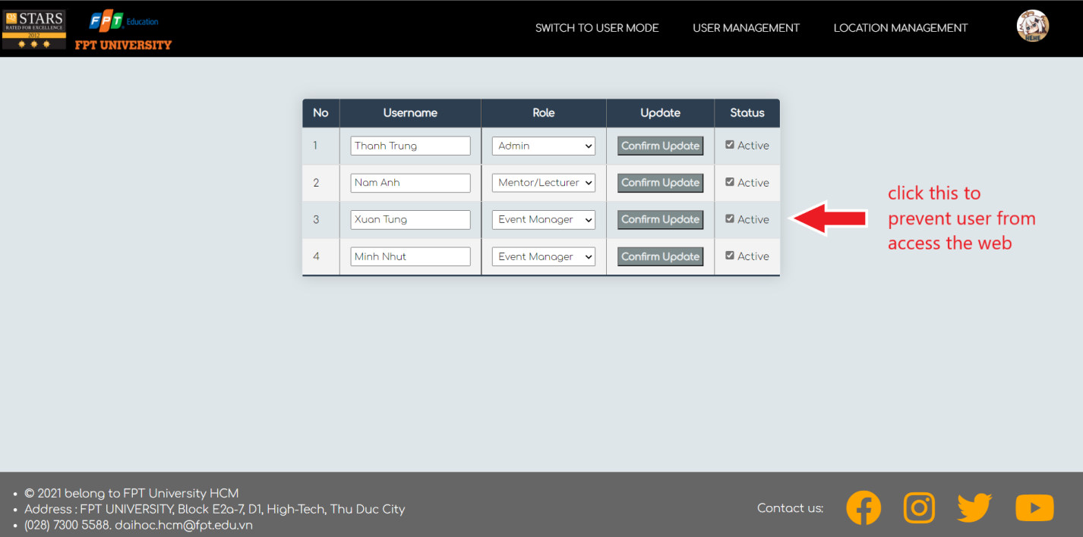

***Figure 22.2a*** *- Deactivate user*

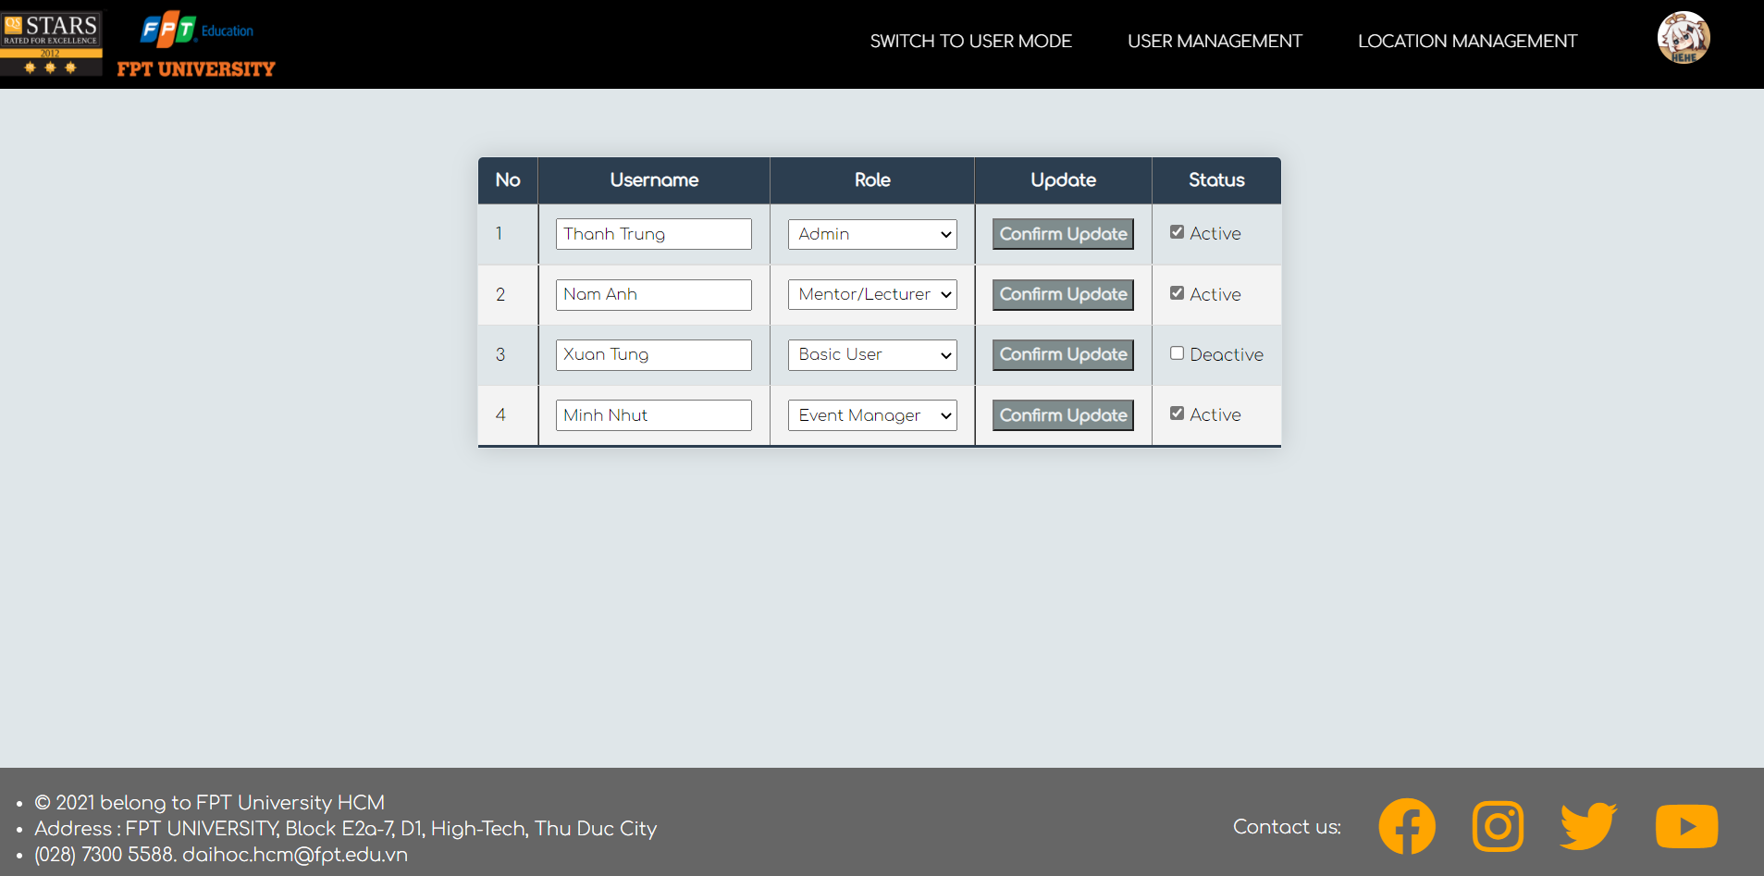

***Figure 22.2b*** *- Deactivate user*

### d. Location management

* *Function trigger: user click ‘Location management’ button on the navigation bar.*
* *Function description: users who have authenticated as admin.*
* *Function details: add new location to celebrate event, edit old location or remove location.*
* *Screen layout:*

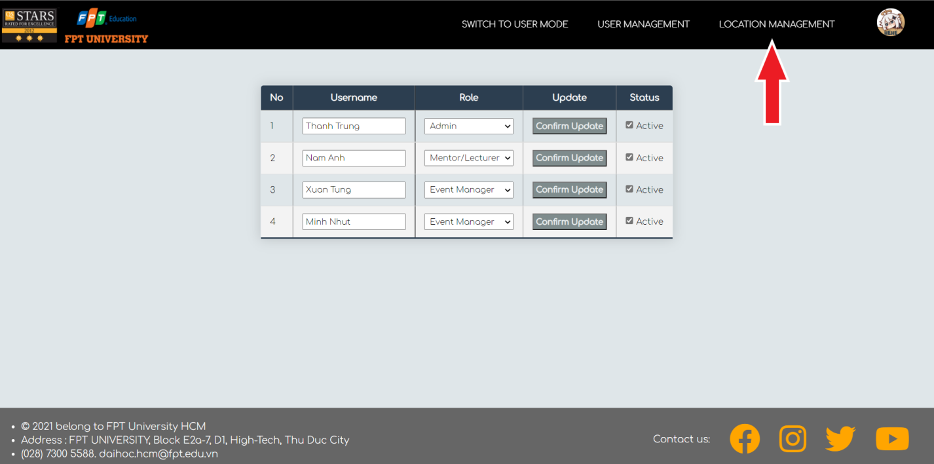

***Figure 23.1*** *- Location management*

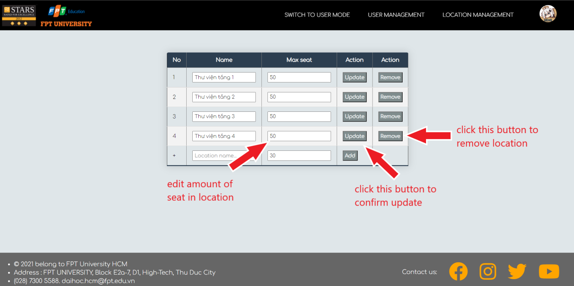

***Figure 23.2*** *- Edit existed location*

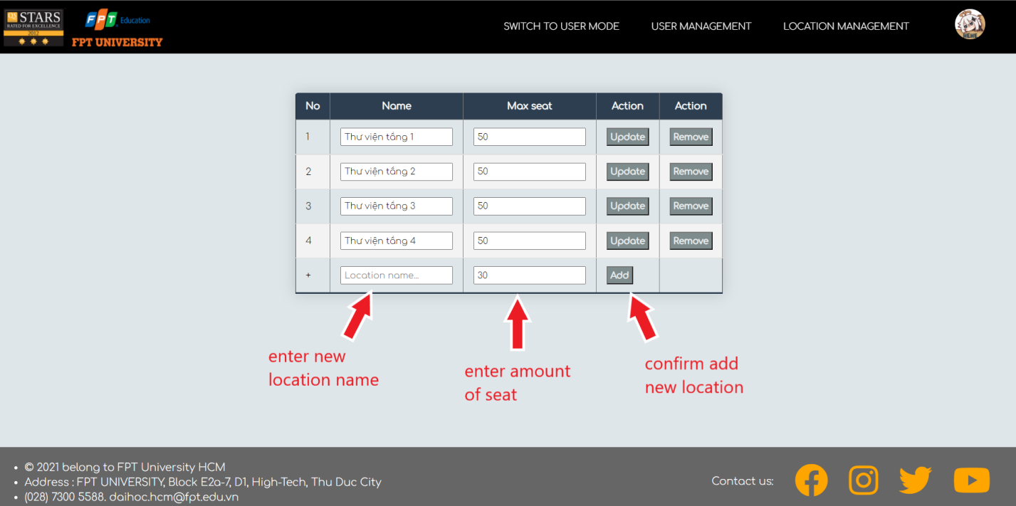

***Figure 23.3*** *- Add new location*

# III. Non-Functional Requirements

## 1. Security

- All users shall be required to log in using @fpt.edu.vn email to access to the website.

- The email for each user must be unique.

- Specified actions must be done by specified role (Administrator can manage user’s accounts while the others cannot).

- Only FPTU members with active @fpt.edu.vn email can log in.

## 2. Performance

- The website must complete each operation within 1-3 seconds.

## 3. External requirements

- New member does not need to register by own as the website shall automatically register @fpt.edu.vn email to the database.

- Include Text editor to enhance user’s experience while creating events or posts. With this Text editor, user can personalize the contents more interesting with pictures, fonts, etc… This Text editor tool is supported by <https://www.tiny.cloud>.